1. Water Jug Problem (4 Gallon and 3 Gallon)
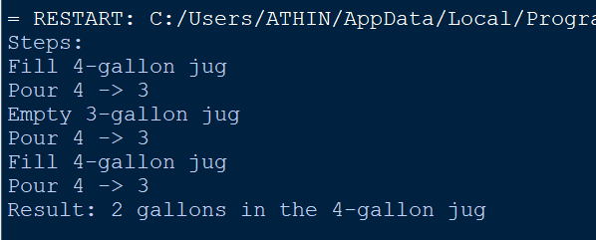

2. Mars Rover Agent


3. 8-Queens Problem
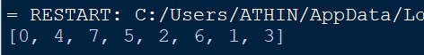
4. OLA Cab Booking Agent
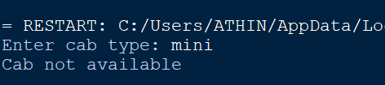
5. Uniform Cost Search (Logistics Network)
